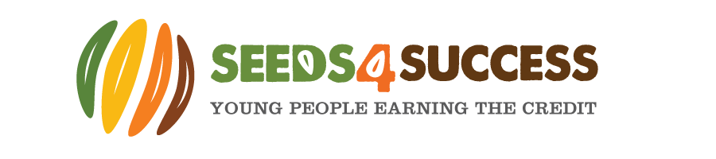
Local Youth Action Scheme (LYAS) – Summer 2022
Sign up form
I confirm that I have received and read the attached information about the proposed LYAS project being delivered by Seeds4Success (S4S) and I consent for my son/daughter/ward ________________________________________ to be involved.
I confirm I have completed and returned a S4S annual membership and consent form for the period 1st Sept 2021 – 30th Sept 2022
I give my permission for my son / daughter / ward to take part in the following listed session and confirm they are available to do so (to the best of my knowledge): (please tick)
Introductory Team Building & Taster Day:
Wednesday 1st June – Raft Building and SUP
Main Programme:
Mon 27th June – Communication /problem solving Weds 29th June – Community Project Planning
Fri 1st July – Mud Trail & inflatable assault course Mon 4th July – Level 2 Award in Food Safety
Tues 5th July – Community Project Planning Day 2 Weds 6th July – Caving Thurs 7th July – Leadership Course – Day 1 Fri 8th July – Leadership Course – Day 2 Mon 11th July – Community Project Day 1 Tues 12th July – Community Project Day 2 Weds 13th July - Community Project Day 3 Thurs 14th July - Community Project Day 4 Weds 15th July – Community Project Day 5 Weds 21st July – Finishing off & review
Fri 5th August – First Aid Course
Reward Residential:
St Davids, Pembrokeshire – 18th – 22nd July

Please provide a mobile number that we can text pick up details to and say whose number this is e.g. young person, parent etc_________________________________________________________________________
Please inform us of any changes to the information provided on the annual consent form:

Please provide emergency contact information for these sessions:

I have completed a current annual consent form and I have provided the most current medical information and an emergency contact number for this activity.
Signed _______________________________ (parent / guardian) Date ______________
Name________________________________ (parent / guardian)

