registered charity number 1151541
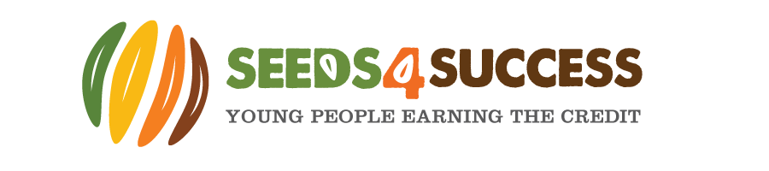
COVID-19 Health Questionnaire and updated parental consent form – updated July 2021

Young Person Personal Details
First Name: |  | Surname:
Date of Birth: |  | Telephone Number:
Address:
Primary Emergency Contact Details
Name |  | Relationship to Young Person
Tel. no |  | Email
Address -if different from YP
Health Questionnaire
Have you had any close contact with or cared for anyone diagnosed with COVID-19 within the last 10 days? | YES |  | NO
Have you been diagnosed with COVID-19 or had a positive COVID 19 swab test within the last 10 days? | YES |  | NO
Have you been in close contact with anyone who has travelled or returned from abroad in the last 10 days? | YES |  | NO
Have you been unwell and experienced Covid 19 symptoms (eg. a cold, sore throat, high temperature (37.8°C), loss of taste or smell or had difficulty breathing) in the last 10 days? | YES |  | NO
Has anyone in your household displayed any of the symptoms indicated above in the last 10 days? | YES |  | NO
Are you or any member of your household classed a clinically vulnerable? | YES |  | NO
Are you or any member of your household classed as clinically extremely vulnerable? | YES |  | NO
Are you or any member of your household currently self-isolating? | YES |  | NO
Are you regularly (twice weekly) self-testing for Covid 19? | YES |  | NO
Do you have a health condition or disability that means you are exempt from wearing a face covering? – if ‘yes’ please discuss this with Jaki as we may need to make some adjustments to sessions to be able to include you | YES |  | NO
Consent & Declaration:
In signing this document, I declare that:
- I am satisfied that Seeds4Success have informed me of their revised procedures and have taken all reasonable steps to reduce the risk of and spread of COVID-19 infection during face to face activities and transport provision
- My child nor anyone living in our household has displayed symptoms of COVID-19 in the past 10 days.
- I understand and accept that my child will be required to adhere to social distancing and personal hygiene practises whilst engaging with Seeds4Success sessions.
- I will inform Seeds4Success immediately if my child or a member of my household displays symptoms of COVID-19 or a member of my household receives a positive COVID-19 swab test result within 10 days of my child attending a face to face session with Seeds4Success.
- My child has not been told to self-isolate within the past 10 days
- I understand and accept that my child will be required to bring a face covering to all face to face sessions run by Seeds4Success and they will be required to wear a facemask when accessing any building used or transport provided by the charity. Exemptions can be discussed with the charity director.
- I appreciate that it is not possible to consider every possible complication of COVID-19 however I have had the opportunity to ask questions about procedures and practises adopted by Seeds4Success
- I will notify Seeds4Success of any changes in my child’s circumstances e.g. they are required to self-isolate or they have a positive test result, as soon as possible
Signature of Parent/Guardian/Carer _____________________________________________________________
Print name:_________________________________________________ Date: ________________________________

Declaration: PARTICIPANT (All)

I, as a participant in the stated activity, agree to abide by the rules and act upon the instructions of staff.

Signature of Participant_____________________________________________________________

Print name:__________________________________________________ Date: ________________________________

